Existing Database
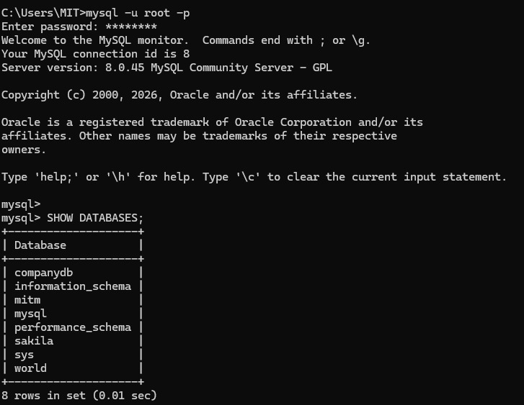
Existing Tables, and Creation of new Tables
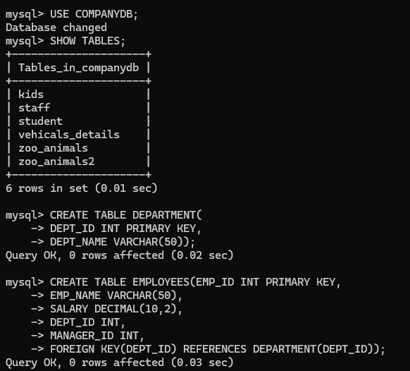
Inserting Values of Departemnt
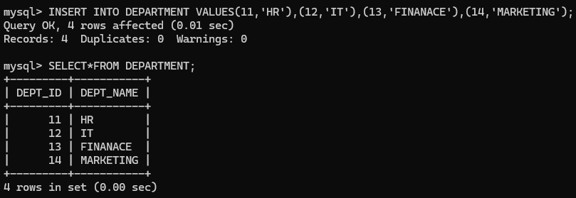
Inserting values into Employees
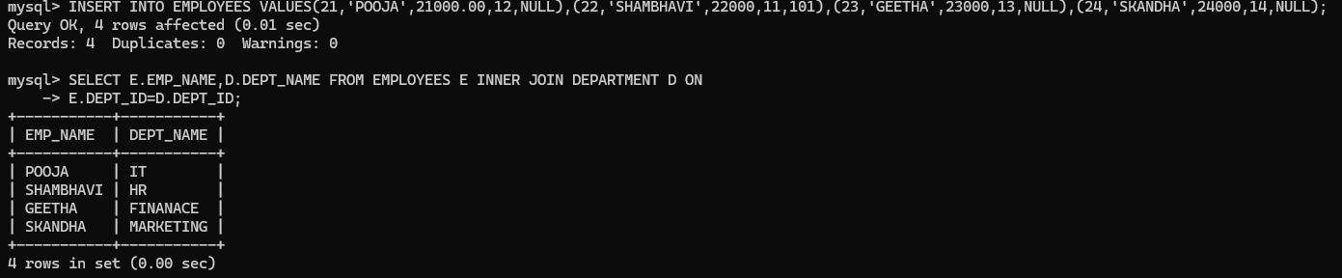
Implementation of Left Join
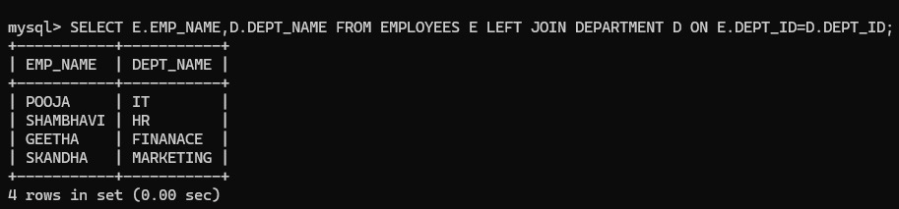
Implementation of Right Join
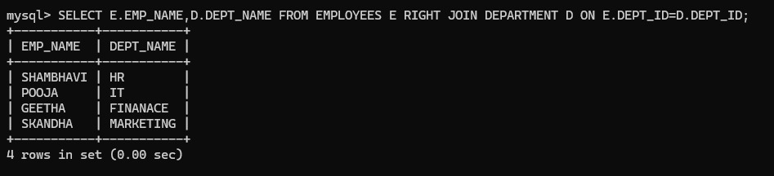

Implemenatation of Full Join
